NIME Proceedings Template for Word

Ben Trovato
Institute for Clarity in
Documentation
1932 Wallamaloo Lane
Wallamaloo, New Zealand trovato@corporation.com

G.K.M. Tobin
Institute for Clarity in
Documentation
P.O. Box 1212
Dublin, Ohio 43017-6221 webmaster@marysville-
ohio.com

Lars Thørväld
The Thørväld Group
1 Thørväld Circle
Hekla, Iceland
larst@affiliation.org

ABSTRACT
This paper provides a sample of a MS Word document for the NIME conference series. It conforms, somewhat loosely, to the formatting guidelines for ACM SIG Proceedings. If possible, we would advise to use the LaTeX template instead of this MS Word template, since LaTeX typically outputs a better looking and more consistent result. The paper submitted to the NIME conference must be stored in an A4-sized PDF file, so North Americans should take care not to inadvertently generate letter paper-sized PDF files.
The abstract should preferably be between 100 and 200 words, a word count that is not too short and not too long. That means that the abstract contains the most important information, so that readers can evaluate whether they are going to read the rest of the paper.

Author Keywords
NIME, proceedings, MS Word, template

INTRODUCTION
The proceedings are the records of the conference. ACM hopes to give these conference by-products a single, high-quality appearance. To do this, we ask that authors follow some simple guidelines. In essence, we ask you to make your paper look exactly like this document. The easiest way to do this is simply to download the template, and replace the content with your own material.

PAGE SIZE
The proceedings are based on the A4 page format (21.0 cm x 29.7 cm). All material on each page should fit within a rectangle centered on the page, beginning 2.54 cm from the top of the page and ending with 2.54 cm from the bottom. The right and left margins should be 1.9 cm. The text should be in two 8.14 cm columns with a .84 cm gutter.

TYPESET TEXT

Normal or Body Text
Please use the styles included with this document (i.e. Heading 1/2/3, etc.) when you typeset your text. The style is based on a 9-point Times New Roman font, or other Roman font with serifs, as close as possible in appearance to Times New Roman in which these guidelines have been set. The goal is to have a 9-point text, as you see here. Please use sans-serif or non-proportional fonts only for special purposes, such as distinguishing source code text. If Times New Roman is not available, try the font named Computer Modern Roman. Right margins should be justified, not ragged.
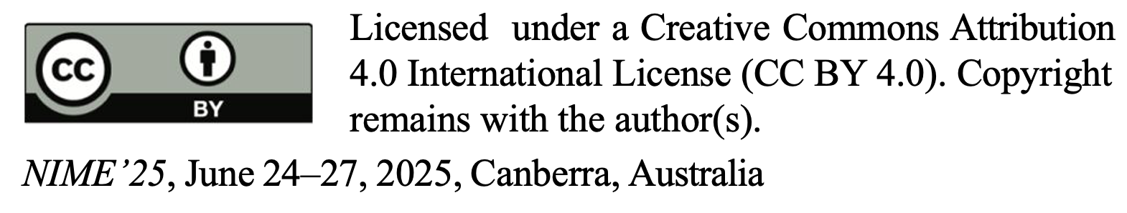

Title and Authors
The title (Helvetica 18-point bold), authors' names (Helvetica 12-point) and affiliations (Helvetica 10-point) run across the full width of the page – one column wide. See the top of this page for three addresses. If only one address is needed, center all address text. For two addresses, use two centered tabs, and so on. For more than three authors, you may have to improvise.

First Page Copyright Notice
Please leave the copyright notice as is.

Subsequent Pages
For pages other than the first page, start at the top of the page, and continue in double-column format. The two columns on the last page should be as close to equal length as possible.

References and Citations
Footnotes should be Times New Roman 9-point, and justified to the full width of the column.
Use the standard Communications of the ACM format for references – that is, a numbered list at the end of the article, ordered alphabetically by first author, and referenced by numbers in brackets [1]. See the examples of citations at the end of this document. Within this template file, use the style named references for the text of your citation.
The references are also in 9 pt., but that section (see Section 7) is ragged right. References should be published materials accessible to the public. Internal technical reports may be cited only if they are easily accessible (i.e. you can give the address to obtain the report within your citation) and may be obtained by any reader. Proprietary information may not be cited. Private communications should be acknowledged, not referenced (e.g., “[Robertson, personal communication]”).

Page Numbering, Headers and Footers
Do not include headers, footers or page numbers in your submission. These will be added when the publications are assembled.

FIGURES/CAPTIONS
Place Tables/Figures/Images in text as close to the reference as possible (see Figure 1). It may extend across both columns.
Captions should be Times New Roman 9-point bold. They should be numbered (e.g., “Table 1” or “Figure 2”), please note that the word for Table and Figure are spelled out. Figure’s captions should be centered beneath the image or picture, and Table captions should be centered above the table body.

Table 1. Table captions should be placed above the table
Graphics | Top | In-between | Bottom
Tables | End | Last | First
Figures | Good | Similar | Very well

SECTIONS
The heading of a section should be in Times New Roman 12-point bold in all-capitals flush left with an additional 6-points of white space above the section head. Sections and subsequent subsections should be numbered and flush left. For a section head and a subsection head together (such as Section 3 and subsection 3.1), use no additional space above the subsection head.

Subsections
The heading of subsections should be in Times New Roman 12-point bold with only the initial letters capitalized. (Note: For subsections and subsubsections, a word like the or a is not capitalized unless it is the first word of the header.)

Subsubsections
The heading for subsubsections should be in Times New Roman 11-point italic with initial letters capitalized and 6-points of white space above the subsubsection head.

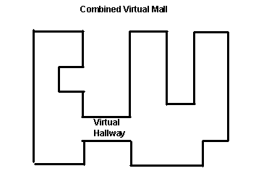
Subsubsubsections
Figure 1. Insert caption to place caption below figure.

.

The heading for subsubsections should be in Times New Roman 11-point italic with initial letters capitalized. Please avoid subsubsubsections.

ANONYMISATION AND BLIND REVIEW
NIME review for the paper and music tracks are double blind;
i.e., the reviewers don’t knowwho the authors are and the authors
don’t know who the reviewers are. To enable this, we ask authors
to ensure that all information that could introduce bias in the
review process is anonymised. All paper category submissions
must be anonymised so that no description or information that
can reveal the authors’ identities is included in the submission
(e.g., detailed descriptions of locations, projects names, linkedwebsites, images with faces of authors). Citations to the authors’previous work should preferably be cited in the third person to enable proper review (e.g., “As described in our previous work [4]” should be “As described by Martin et al. [4]).

If this is not possible, specific references may be anonymized like this:
[1] Anonymised Author A and Anonymised Author B. YYYY.
ANONYMISED: a Software Package for Technical Computations,
version N. Retrieved Month DD, YYYY from http://anonymised.edu/path/index.html

ACKNOWLEDGMENTS
Our thanks to ACM SIGCHI for allowing us to modify templates they had developed.

ETHICAL STANDARDS
To ensure objectivity and transparency in research and to ensure
that accepted principles of ethical and professional conduct have
been followed, authors must include a section “Ethical Standards” before the References. This section should include (if relevant): information regarding sources of funding, potential conflicts of interest (financial or non-financial), informed consent if the research involved human participants, statement on welfare of animals if the research involved animals or any other information or context that helps ethically situate your research. For help with the ethics section, feel free to ask on the NIME forum: https://forum.nime.org.

ADDITIONAL AUTHORS
Because of the available 'opening page real-estate' we ask you to refrain from putting more than six authors (two rows with three columns) beneath the article title. More than six makes the first-page appear very cluttered indeed. Additional authors can be placed in a section between the acknowledgments and references.
Additional authors: John Smith (The Thørva ̈ld Group, email: jsmith@affiliation.org) and Julius P. Kumquat (The Kumquat Consortium, email: jpkumquat@consortium.net).

REFERENCES
- B. Bowman, S.K. Debray, and L. L. Peterson. Reasoning about naming systems. ACM Trans. Program. Lang. Syst., 15, 5 (Nov. 1993), 795-825.
- W. Ding, and G. Marchionini. A Study on Video Browsing Strategies. Technical Report UMIACS-TR-97-40, University of Maryland, College Park, MD, 1997.
- B. Fröhlich and J. Plate. The cubic mouse: a new device for three-dimensional iput. In Proceedings of the SIGCHI conference on Human factors in computing systems
(CHI ’00) (The Hague, The Netherlands, April 1-6, 2000). ACM Press, New York, NY, 2000, 526-531.
- L. Lamport. LaTeX User’s Guide and Document Reference Manual. Addison-Wesley, Reading, MA, 1986.
- M.L. Sannella. Constraint Satisfaction and Debugging for Interactive User Interfaces. Ph.D. Thesis, University of Washington, Seattle, WA, 1994.

Appendices may follow the references
If you want to include some extra information that does not go into the main document, you may put it here in an appendix. Or you may have pointers to a web location with additional information, program code, sound/video examples, etc.

